**ALCOHOL DETECTION WITH ENGINE LOCKING SYSTEM**

**A MINI PROJECT REPORT**

**SUBMITTED BY**

**SUNDARAVALLI S (111620106102)**

**SRUTHE K (111620106101)**

**SOWMYA B (111620106096)**

**BE ELECTRONICS AND COMMUNICATION ENGINEERING**

**R.M.K COLLEGE OF ENGINEERING AND TECHNOLOGY**

**(AN AUTONOMOUS INSTITUTION)**

**TABLE OF CONTENTS**

* **ABSTRACT**
* **INTRODUCTION**
* **COMPONENTS REQUIRED**
* **BLOCK DIAGRAM**
* **CIRCUIT**
* **ADVANTAGES**
* **APPLICATIONS**
* **CONCLUSION**

**ABSTRACT**

**It is not uncommon to pick up the newspaper and read about a road accident. In fact, India holds the world record in the number of road accidents annually, according to a report released by the WHO in 2010. Around 1,34,000 people die every year in India on account of road accidents. The most shocking fact is that 70% of these are due to the consumption of alcohol, according to a report released in 2011.**

**In this project, we will go over how to build an alcohol sensor with an Arduino. The alcohol sensor we will use is the MQ-3 sensor. This is a sensor that is not only sensitive to alcohol, particularly ethanol, which is the type of alcohol that is found in wine, beer, and liquor.**

**This type of sensor circuit can be used as a breathanalyzer to check a person’s blood-alcohol level. Just as we exhale carbon dioxide when we breathe out, we also will breathe out some alcohol if we have alcohol in our blood. Any alcometer device can measure this alcohol content. The more ethanol in your blood, the more there is in the air on exhalation. This alcohol content gives a good indication of if a person is drunk**

**INTRODUCTION**

* **The main purpose for this project is “Automatic Engine Locking System Through Alcohol Detection using Arduino”.**
* **Most of these days many accidents are happening because of the alcohol detection of the driver or the person who is in the vehicle.**
* **Almost all the countries in the world are facing major accidents because of Drunk & Drive.**
* **This project is designed for safety of the people seating in the vehicle.**

**COMPONENTS REQUIRED**

* **Arduino Uno**
* **Mq3 alcohol sensor**
* **Relay module 5v**
* **PCB**
* **Battery with a clip**
* **Motor with propeller**
* **Jumper wires**
* **Push button**

**ARDUINO UNO**

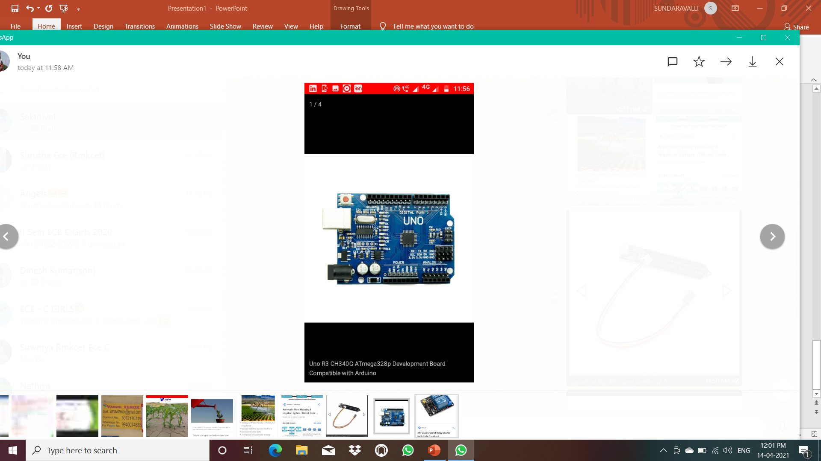

* **The ARDUINO UNO is an open-source microcontroller board based on the microcontroller and developed by Arduino.**
* **The board is equipped with sets of digital and analog input/output (I/O) pins that may be interfaced to various expansion boards (shields) and other circuits.**
* **The board has 14 digital I/O pins 6 analog I/O pins, and is programmable with the Arduino IDE (Integrated Development Environment), via a type USB cable. It can be powered by a USB cable or by an external 9-volt battery.**

**RELAY**

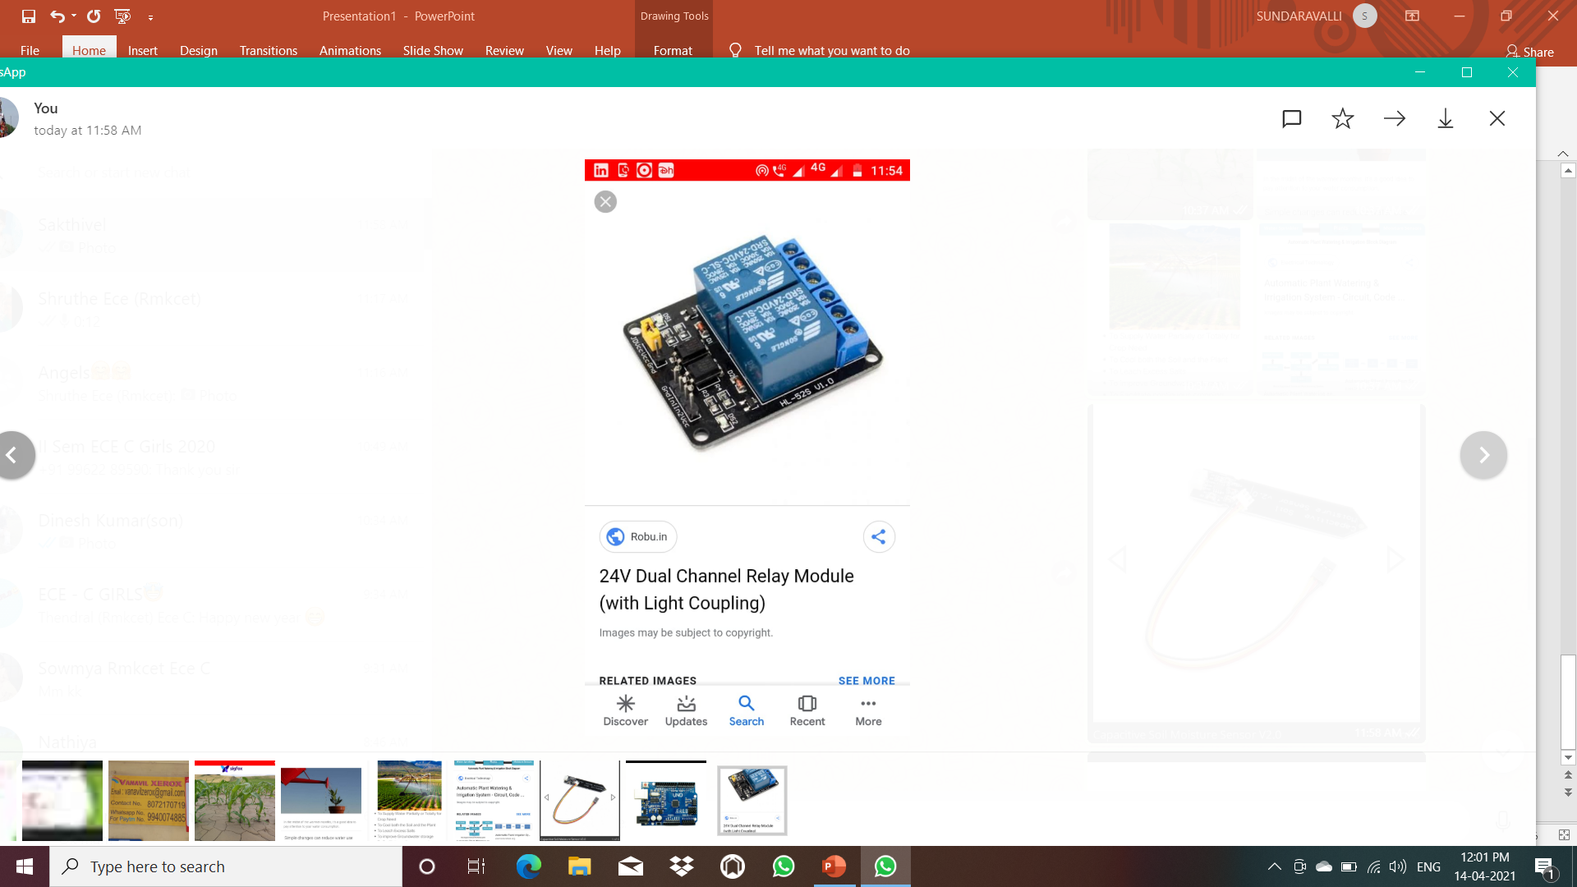

* **A relay is an electrically operated switch It consists of a set of input terminals for a single or multiple control signals and a set of operating contact terminals.**
* **Relays are used where it is necessary to control a circuit by an independent low-power signal, or where several circuits must be controlled by one signal.**
* **Relays were first used in long-distance telegraph circuits as signal repeaters they refresh the signal coming in from one circuit by transmitting it on another circuit.**

**MQ 3 Alcohol sensor**

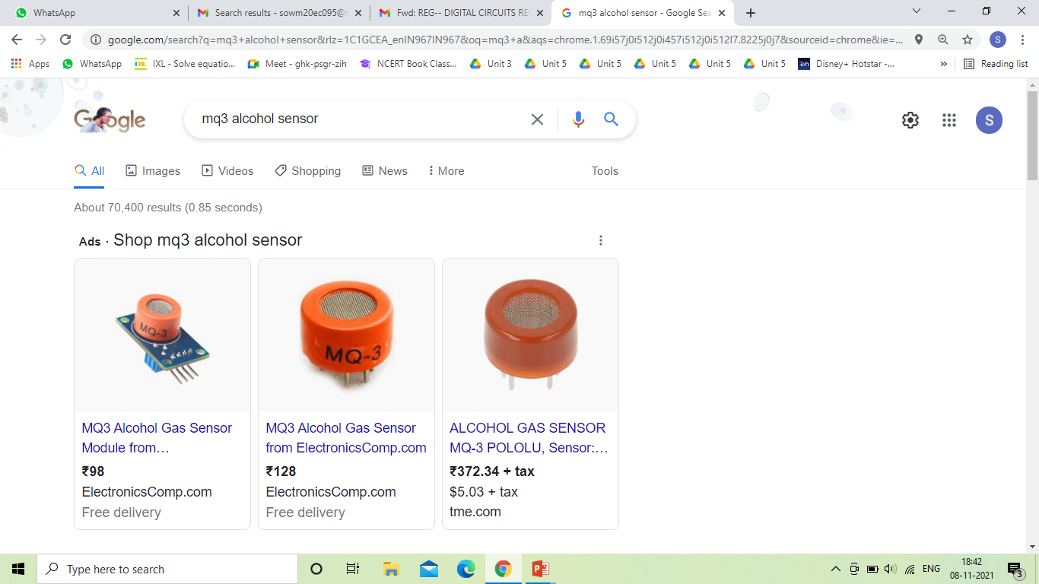

* **This module is made using Alcohol Gas Sensor MQ3. It is a low cost semiconductor sensor which can detect the presence of alcohol gases at concentrations from 0.05 mg/L to 10 mg/L.**
* **The sensitive material used for this sensor is SnO2, whose conductivity is lower in clean air. It’s conductivity increases as the concentration of alcohol gases increases.**
* **It has high sensitivity to alcohol and has a good resistance to disturbances due to smoke, vapor and gasoline. This module provides both digital and analog outputs.**
* **MQ3 alcohol sensor module can be easily interfaced with Microcontrollers, Arduino Boards, Raspberry Pi etc.**

**BLOCK DIAGRAM**

PUSH BUTTON

IGNITION (DC GEAR MOTOR)

5V RELAY MODULE

ARDUINO UNO

ALCOHOL SENSOR

**CIRCUIT**

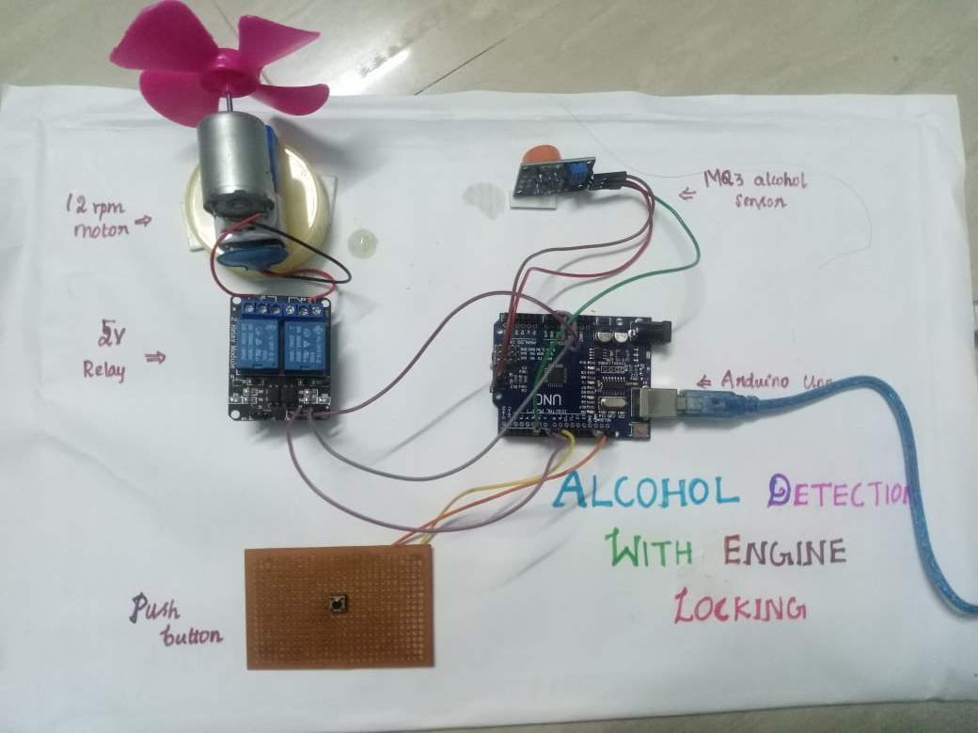

**WORKING**

* **The Alcohol Detection with Engine Locking system helps to reduce accidents which are occurring due to drunk driving. MQ-3 sensor detects the presence of alcohol in the surroundings.**
* **The sensor provides an output on the basis of the concentration of the alcohol, if the alcohol concentration is higher the conductivity of the MQ-3 sensor increases which in turn gives the reading to ARDUINO.**
* **If the reading is greater than the threshold level, ARDUINO will stop the DC motor.**

**ADVANTAGES**

* LOW COST
* AUTOMATED OPERATION
* LOW POWER CONSUMPTION
* IT PROVIDES AUTOMATIC SAFETY SYSTEM FOR CAR AND OTHER VEHICLES AS WELL

**APPLICATIONS**

* “Alcohol detector project”, can be used in various vehicles for detecting the driver whether he consumed alcohol or not.
* This project can also be used in various companies or organization to detect alcohol consumption of employees.

**CONCLUSION**

* Thus alcohol detection with an engine locking system is a combination of an economically effective and technology.
* Alcohol sensing element provides a signal to the microcontroller and it is connected to DC motor which will automatically stop.
* We can conclude that by using this project the accidents through drunk and drive can be minimized.

THANK YOU